Unit 3 : Multimedia Compression Techniques
Multimedia compression techniques are essential for efficiently storing and transmitting various types of media, including images, audio, and video. Compression is the process of reducing the size of a file or data set to occupy less storage space or transmit more efficiently. It involves encoding data in a more compact representation, which can be restored to its original form when needed. Compression techniques are widely used in data storage, data transmission, and multimedia applications.
What Is Data Compression ?
Data compression is the process of reducing the size of digital data files without significantly changing their content or properties. The primary goals of data compression are to optimize storage requirements, enhance data transmission speeds, and improve overall data processing efficiency.
- Fundamentals of compression:
Need for Compression
Compression is essential for multimedia applications due to the large size of audio, video, and image files. Here are some key reasons why compression is necessary:
- Storage Requirements: Uncompressed multimedia files can be extremely large, often requiring several gigabytes of storage space. For example, a single uncompressed video file could be over 225GB in size. Compression techniques can significantly reduce the storage requirements, making it feasible to store and manage these files.
- Transmission Speeds: Transmitting uncompressed multimedia files over networks would be very slow and inefficient. Compression helps reduce the file sizes, enabling faster transmission speeds and better utilization of available bandwidth. This is crucial for applications like video streaming, where smooth playback requires continuous data delivery.
- Efficient Data Management: Compression allows for more effective management of large volumes of multimedia data. It enables storing more files in a given storage space and transmitting more data over a network in a shorter time. This is particularly important in scenarios with limited storage or bandwidth resources.
- Multimedia Formats: Many popular multimedia formats, such as MP3 for audio and JPEG for images, rely on compression to achieve their compact file sizes. These formats use lossy compression techniques that discard some data deemed less important to the human senses, allowing for higher compression ratios while maintaining acceptable quality.
- Compatibility: Standardized compression formats enable compatibility between different devices, software, and platforms. Users can easily share and exchange multimedia files knowing they will be playable on various systems.

- Taxonomy of compression Algorithms
Compression algorithms can be classified into various categories based on their characteristics and the types of data they handle. Here is a taxonomy of compression algorithms:
1. Lossless Compression Algorithms
Lossless compression algorithms reduce file sizes without losing any data. The original data can be perfectly reconstructed from the compressed data. Common methods include:
- Huffman Coding: Utilizes variable-length codes for encoding symbols based on their frequency of occurrence, where more frequent symbols have shorter codes.
- Lempel-Ziv-Welch (LZW): A dictionary-based compression algorithm that replaces repeated occurrences of data with references to a single copy stored in a dictionary.
- Run-Length Encoding (RLE): Compresses data by replacing sequences of the same value with a single value and a count, effective for data with many consecutive repeated elements.
- Arithmetic Coding: Represents a sequence of symbols as a single number in the interval [0, 1), providing more efficient encoding than Huffman coding in some cases.
2. Lossy Compression Algorithms
- Lossy Compression
- Lossy compression algorithms achieve higher compression ratios by selectively discarding some data that is considered less important. This results in a loss of information, but the decompressed data may still be acceptable for certain applications, such as images, audio, and video. Lossy compression is often used in multimedia applications to reduce file sizes while maintaining acceptable quality. Examples of lossy compression techniques include:
- Transform Coding (e.g., DCT used in JPEG)
- Predictive Coding (e.g., used in MPEG video)
- Quantization
- Error Free Compression
What is Error-Free (Lossless) Compression?
Error-Free Compression means compressing multimedia data without losing any information. After decompression, the original data is restored exactly as it was. It is also called Lossless Compression.
It is a technique that reduces the size of data without losing any information. The original data can be perfectly reconstructed from the compressed data. This makes it suitable for applications where data integrity is crucial, such as text files, executable files, and medical images. Lossless compression typically achieves compression ratios ranging from 2:1 to 10:1, depending on the characteristics of the data. It works by removing coding redundancy and interpixel redundancy present in the original data.
Techniques Used in Error-Free Compression
1. Run Length Encoding (RLE)
- Replaces repeated values with count and value.
- Used in simple image formats (e.g., BMP, TIFF).
Example:
AAAAA → 5A
2. Huffman Coding
- Assigns shorter codes to frequent symbols.
- Widely used in image and audio compression.
3. Arithmetic Coding
- Represents entire message as a single fractional value.
- More efficient than Huffman in some cases.
4. Lempel-Ziv (LZ) Coding
- Replaces repeated patterns with references.
- Used in ZIP files and PNG images.

- Types of Data Compression
Data compression can be categorized into two main types:
- Lossless Compression: Allows the original data to be perfectly reconstructed from the compressed data. This is important for applications where data integrity is critical, such as text documents and executable files.
What is Lossless data compression
Lossless data compression is used to compress the files without losing an original file's quality and data. Simply, we can say that in lossless data compression, file size is reduced, but the quality of data remains the same.
The main advantage of lossless data compression is that we can restore the original data in its original form after the decompression.
Lossless data compression mainly used in the sensitive documents, confidential information, and PNG, RAW, GIF, BMP file formats.
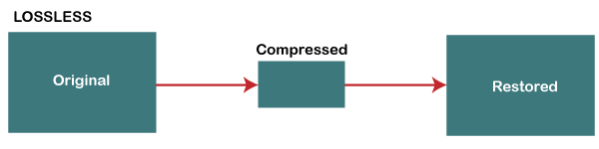
Some most important Lossless data compression techniques are -
- Run Length Encoding (RLE)
- Lempel Ziv - Welch (LZW)
- Huffman Coding
- Arithmetic Coding

How Lossless Compression Works
Lossless compression algorithms identify and eliminate redundancy in data without losing any essential information. The process typically involves the following steps:
- Data Analysis: The algorithm analyzes the data to find patterns and redundancies. For example, repeated sequences of characters in text files or similar pixel values in images.
- Encoding: The algorithm encodes the data using various techniques, such as:
  - Run-Length Encoding (RLE): This technique replaces sequences of repeated data with a single value and a count. For instance, "AAAABBBCCDAA" could be encoded as "4A3B2C1D2A".
  - Huffman Coding: This method assigns variable-length codes to input characters based on their frequencies, with more common characters receiving shorter codes.
  - Lempel-Ziv-Welch (LZW): This algorithm builds a dictionary of sequences and replaces repeated occurrences of data with references to the dictionary.
- Storage: The compressed data is then stored or transmitted. Since it retains all original information, it can be decompressed back to its exact original form.
- Decompression: When the data is needed again, the algorithm reconstructs the original data from the compressed format using the same method in reverse.
Advantages of Lossless Compression
- Data Integrity: The primary advantage is that no data is lost during the compression process, making it suitable for text files, executable files, and any other data where accuracy is critical.
- Reversibility: Lossless compression allows for perfect reconstruction of the original data, which is essential for applications like software distribution, medical imaging, and text documents.
- Minor File Size Reduction: While lossless compression typically achieves smaller file sizes than the original, it may not reduce sizes as significantly as lossy methods. However, it is still effective for many applications.
Disadvantages of Lossless Compression
- Larger File Sizes Compared to Lossy Compression: Lossless files are generally larger than lossy compressed files, which can be a drawback for storage and transmission when file size is a priority.
- Less Effective for Multimedia: Lossless compression is less efficient for multimedia files (like images, audio, and video) compared to lossy methods, which can achieve much higher compression ratios.
Applications of Lossless Compression
Lossless compression is commonly used in various fields, including:
- Text Files: Ideal for documents, spreadsheets, and any textual data where accuracy is essential.
- Images: Formats like PNG and GIF use lossless compression, preserving image quality while reducing file sizes.
- Audio: Formats such as FLAC and ALAC provide lossless audio compression, maintaining the original sound quality.
- Software and Data Archives: Used for compressing software packages and data backups to ensure integrity and recoverability.

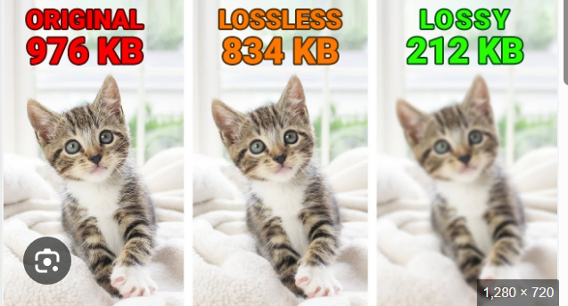

- Lossy Compression: Lossy compression is a crucial technique used in multimedia to reduce file sizes by permanently removing some data, resulting in a smaller file that approximates the original.
This type of compression is commonly used for multimedia files like images, audio, and video, where some loss of quality is acceptable in exchange for significantly reduced file sizes.
Lossy data compression is used to compress larger files into smaller files. In this compression technique, some specific amount of data and quality are removed (loss) from the original file. It takes less memory space from the original file due to the loss of original data and quality. This technique is generally useful for us when the quality of data is not our first priority.
Lossy data compression is most widely used in JPEG images, MPEG video, and MP3 audio formats.
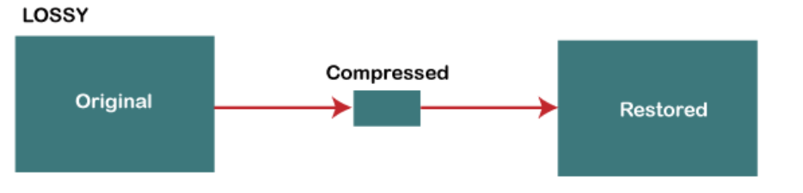
Some important Lossy data compression techniques are -
- Transform coding
- Discrete Cosine Transform (DCT)
- Discrete Wavelet Transform (DWT)
Key Techniques
- Transform Coding: This method involves breaking down the multimedia content into smaller segments, which are then transformed mathematically. The most common algorithm used is the Discrete Cosine Transform (DCT), which converts spatial data (like pixel values in images) into frequency components. This allows the compression algorithm to identify and discard less significant frequencies, which are less perceptible to human senses.
- Quantization: This is the critical step in lossy compression where the range of values is reduced. During quantization, certain data points are approximated or discarded altogether. There are different forms of quantization:
  - Uniform Quantization: Divides the input range into equal intervals.
  - Non-Uniform Quantization: Uses variable intervals based on the importance of the data.
  - Vector Quantization: Groups data points into vectors and compresses them as a single entity.
- Predictive Coding: This technique uses previously decoded data to predict the current data, reducing redundancy and further compressing the file.
Compression Ratios and Quality Metrics
The effectiveness of lossy compression is often measured by the compression ratio and various quality metrics:
- Compression Ratio: This indicates how much the file size has been reduced, with higher ratios signifying more aggressive compression.
- Perceptual Distortion: This metric assesses how much the quality has degraded from the original. Well-designed lossy compression aims for minimal perceptual distortion, making it hard for users to notice any quality loss.
- Mean Square Error (MSE) and Peak Signal-to-Noise Ratio (PSNR): These are quantitative measures used to evaluate the quality of the compressed file. Higher PSNR values generally indicate better quality, with values around 30-50 dB considered acceptable for video.
Applications in Multimedia
Lossy compression is widely used in various multimedia formats:
- Images: JPEG is a standard format that employs lossy compression, allowing for significant size reductions with minimal visible quality loss.
- Audio: Formats like MP3 and AAC utilize lossy compression to reduce file sizes for music and audio streaming while maintaining acceptable sound quality.
- Video: Standards such as H.264, H.265, and VP9 are lossy compression algorithms that enable efficient streaming and storage of high-definition video content
- Difference between lossless and lossy data compression
As we know, both lossless and lossy data compression techniques are used to compress data form its original size. The main difference between lossless and lossy data compression is that we can restore the lossless data in its original form after the decompression, but lossy data can't be restored to its original form after the decompression.
The below table shows the difference between lossless and lossy data compression -
S.No | Lossless data compression | Lossy data compression
1. | In Lossless data compression, there is no loss of any data and quality. | In Lossy data compression, there is a loss of quality and data, which is not measurable.
2. | In lossless, the file is restored in its original form. | In Lossy, the file does not restore in its original form.
3. | Lossless data compression algorithms are Run Length Encoding, Huffman encoding, Shannon fano encoding, Arithmetic encoding, Lempel Ziv Welch encoding, etc. | Lossy data compression algorithms are: Transform coding, Discrete Cosine Transform, Discrete Wavelet Transform, fractal compression, etc.
4. | Lossless compression is mainly used to compress text-sound and images. | Lossy compression is mainly used to compress audio, video, and images.
5. | As compare to lossy data compression, lossless data compression holds more data. | As compare to lossless data compression, lossy data compression holds less data.
6. | File quality is high in the lossless data compression. | File quality is low in the lossy data compression.
7. | Lossless data compression mainly supports RAW, BMP, PNG, WAV, FLAC, and ALAC file types. | Lossy data compression mainly supports JPEG, GIF, MP3, MP4, MKV, and OGG file types.

- Text compression: Huffman coding:
Huffman coding is a widely used algorithm for lossless data compression, particularly effective for text files. Developed by David A. Huffman in 1952, this algorithm reduces the size of a file by assigning variable-length codes to input characters based on their frequencies. Here’s an overview of how Huffman coding works.
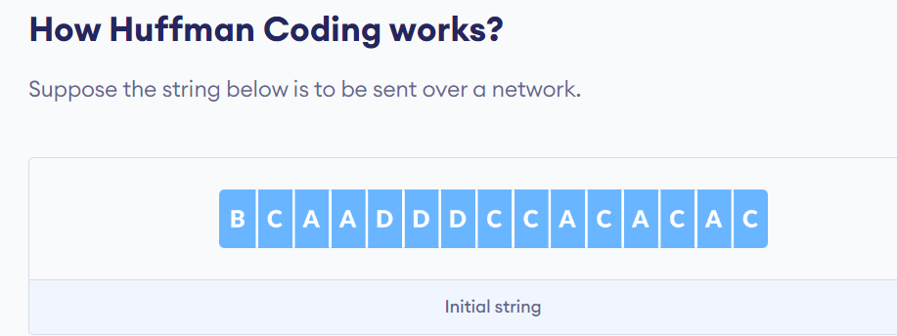
Each character occupies 8 bits. There are a total of 15 characters in the above string. Thus, a total of 8 * 15 = 120 bits are required to send this string.
Using the Huffman Coding technique, we can compress the string to a smaller size.
Huffman coding first creates a tree using the frequencies of the character and then generates code for each character.
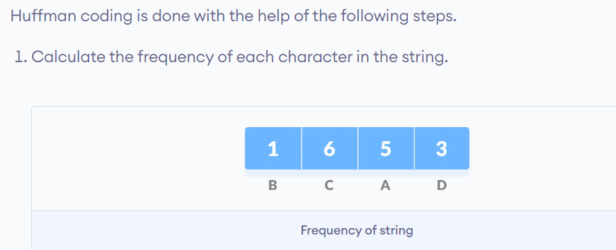
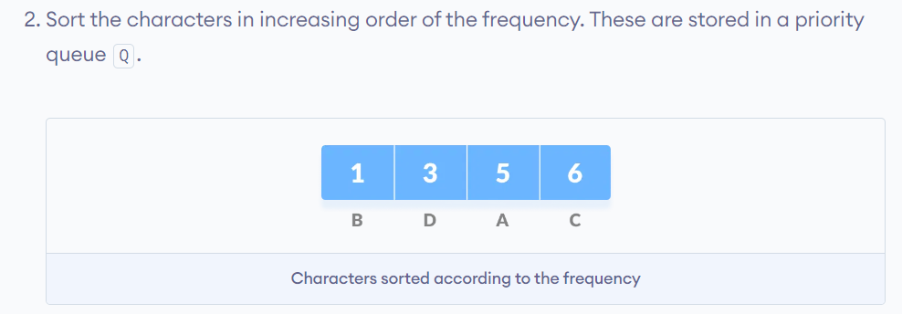
- Make each unique character as a leaf node.
- Create an empty node z. Assign the minimum frequency to the left child of z and assign the second minimum frequency to the right child of z. Set the value of the z as the sum of the above two minimum frequencies.
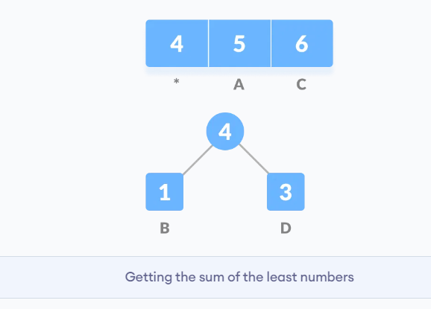
- Remove these two minimum frequencies from Q and add the sum into the list of frequencies (* denote the internal nodes in the figure above).
- Insert node z into the tree.
- Repeat steps 3 to 5 for all the characters.
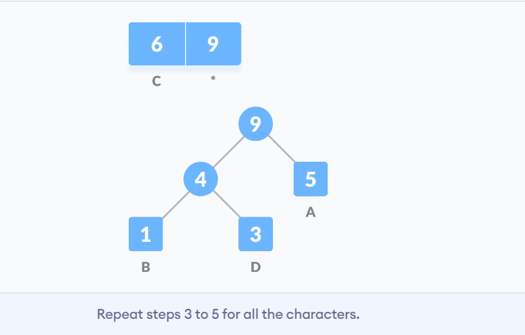
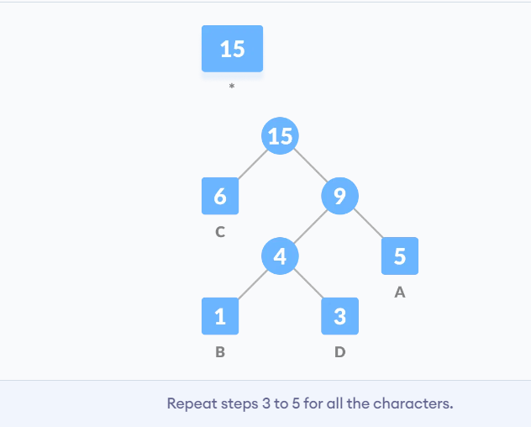
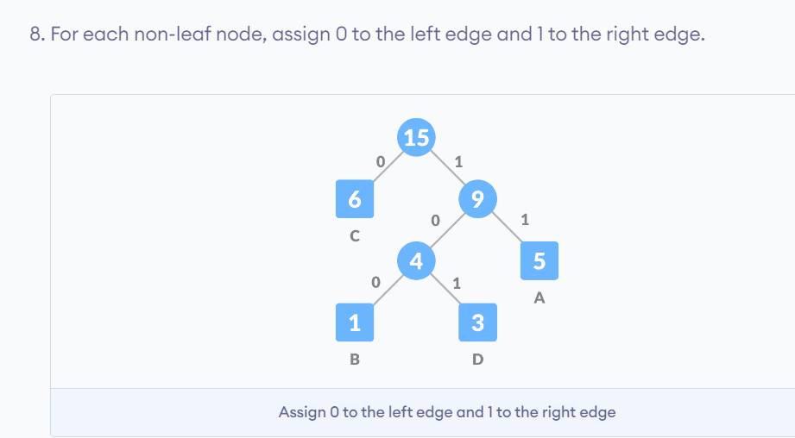
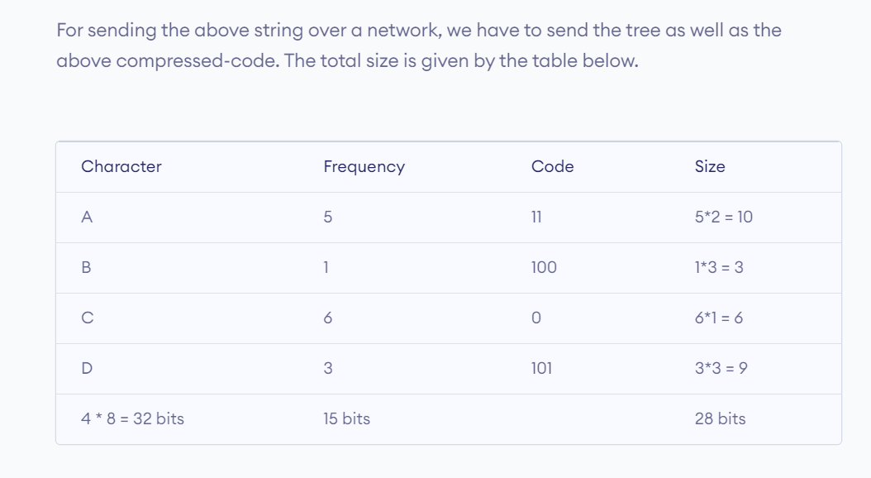
- Without encoding, the total size of the string was 120 bits. After encoding the size is reduced to 32 + 15 + 28 = 75.
Ques: Construct the Huffman Tree and find the Huffman Codes for:
Symbol | Frequency
A | 8
B | 3
C | 7
D | 6
E | 2

✅ Step 1: Arrange in Ascending Order
E-2, B-3, D-6, C-7, A-8
✅ Step 2: Combine Smallest Frequencies
🔹 Iteration 1
E(2) + B(3) = 5
New list: 5, 6, 7, 8
🔹 Iteration 2
5 + D(6) = 11
New list: 7, 8, 11
🔹 Iteration 3
C(7) + A(8) = 15
New list: 11, 15
🔹 Iteration 4
11 + 15 = 26 (Root)
Final Huffman Tree (Box Format)
[26]
/ \
[11] [15]
/ \ / \
[5] [6] [7] [8]
/ \ D C A
[2] [3]
E B
Step 3: Assign Codes
(Left = 0, Right = 1)
Symbol | Code
E | 000
B | 001
D | 01
C | 10
A | 11

Final Huffman Codes
A = 11
B = 001
C = 10
D = 01
E = 000
Average Code Length
$$=\frac{\left(8×2)+(3×3)+(7×2)+(6×2)+(2×3\right)}{26} \\ =\frac{16+9+14+12+6}{26} \\ =\frac{57}{26}=2.19\text{ bits/symbol (approx)}$$
Ques: Construct the Huffman Tree and find the Huffman Codes for:
Symbol | Frequency
A | 5
B | 9
C | 12
D | 13
E | 16
F | 45

Step 1: Arrange in Ascending Order
A-5, B-9, C-12, D-13, E-16, F-45
Step 2: Combine Smallest Frequencies
Iteration 1
A(5) + B(9) = 14
Iteration 2
C(12) + D(13) = 25
Iteration 3
14 + E(16) = 30
Iteration 4
25 + 30 = 55
Iteration 5
F(45) + 55 = 100 (Root)
Final Huffman Tree (Box Format)
[100]
/ \
[45] [55]
F / \
[25] [30]
/ \ / \
[12] [13][14] [16]
C D / \ E
[5] [9]
A B
Step 3: Assign Codes
(Left = 0, Right = 1)
Symbol | Code
F | 0
C | 100
D | 101
A | 1100
B | 1101
E | 111
Final Huffman Codes
A = 1100
B = 1101
C = 100
D = 101
E = 111
F = 0
Average Code Length
$$=\frac{\left(5×4)+(9×4)+(12×3)+(13×3)+(16×3)+(45×1\right)}{100} \\ =\frac{20+36+36+39+48+45}{100} \\ =\frac{224}{100}=2.24\text{ bits/symbol}$$
Ques: Construct the Huffman Coding for the sentence:
"MULTIMEDIA SYSTEMS ARE POWERFUL"
(Consider space as a character)

Image Compression:
Image compression is a crucial process in digital image processing that aims to reduce the amount of data required to represent an image. This reduction not only saves storage space but also facilitates faster transmission over networks. The fundamentals of image compression can be categorized into several key concepts, techniques, and applications.
Image compression is the process of reducing the amount of data required to represent a digital image without degrading the quality of the image below an acceptable level. The main goals of image compression are to:
- Reduce the storage space required for images
- Reduce the time and bandwidth required to transmit images over a communication link
Image compression reduces image file size for storage and transmission by removing data redundancy, utilizing either lossy (high compression, some quality loss) or lossless (no quality loss) methods.
- Compression Standards
Image compression standards are essential for reducing file sizes while maintaining image quality, enabling efficient storage and transmission. The three most commonly used image formats are JPEG, PNG, and GIF, each with distinct characteristics and use cases. Compression standards are essential in managing the size and quality of digital images and videos.

Core Image Compression Standards & Methods
- JPEG-2000: JPEG 2000 is a wavelet-based image compression standard (J2K, JP2, JPX) that offers superior quality, especially at low bit rates, compared to the original JPEG format. It supports both lossy and lossless compression within a single codestream and features progressive transmission by resolution and pixel accuracy, ideal for high-quality imaging, medical, and web applications.
Wavelet-Based Compression: Unlike the traditional DCT-based JPEG, JPEG 2000 uses Discrete Wavelet Transform (DWT), which reduces blocking artifacts and provides better image quality, particularly at low bit rates.
Lossy and Lossless: Provides a single architecture for both lossy (high compression, some data loss) and lossless (perfect reconstruction) compression, allowing for flexibility in image fidelity.
Progressive Transmission: Supports decoding an image progressively from low to high resolution, enabling faster loading of images on the web, also known as SNR scalability.
Region of Interest (ROI) Coding: Enables specific areas of an image to be encoded with higher quality than the rest of the image.
Applications: Widely used in digital cinema (DCPs), medical imaging (DICOM), geospatial imagery (GIS), and high-quality archiving due to its robustness to bit errors and advanced features
- JPEG-LS: JPEG-LS (ISO-14495-1/ITU-T.87) is an international standard for lossless and near-lossless continuous-tone image compression, prioritizing low-complexity hardware implementation and high-speed encoding. Based on the LOCO-I (Low Complexity Lossless Compression for Images) algorithm, it provides superior compression ratios to older standards while maintaining a smaller footprint, commonly used in medical imaging, satellite, and archival applications.
- Key features and details:
- Methodology: Uses predictive coding (specifically, the Median Edge Detector/MED predictor) and context-based modeling to efficiently encode residuals.
- Efficiency: Achieves compression ratios similar or superior to JPEG 2000, often outperforming PNG.
- Near-Lossless Mode: Allows users to set a maximum acceptable error, facilitating higher compression rates while ensuring visually identical images (lossy).
- Standards: Comprises two parts—ISO/IEC 14495-1 (Core) and 14495-2 (Extensions)
- Other Formats: While not standards, formats like GIF and PNG represent specific compression techniques (palette-based).
- Techniques: Lossy compression often involves DCT, quantization, and chroma subsampling, where the human eye's reduced sensitivity to color changes is exploited.
- JPEG (Joint Photographic Experts Group)
JPEG, which stands for Joint Photographic Experts Group, is a widely used standard for lossy image compression. It was developed to reduce the file size of images while maintaining acceptable quality, making it essential for digital photography and web applications.
- Compression Method: JPEG uses a technique called Discrete Cosine Transform (DCT), which breaks down an image into its frequency components. This allows the algorithm to discard less important information, particularly details that are less perceptible to the human eye, thus achieving significant file size reduction.
- Color Support: JPEG supports up to 24-bit color, allowing for approximately 16 million colors, making it suitable for photographs and images with rich color variations.
- File Extensions: Common file extensions for JPEG images include .jpg, .jpeg, .jpe, .jfif, and .jfi
Key Steps in JPEG Compression:
- Color Space Conversion & Downsampling: The image is converted from RGB to Y Cr Cb (luminance and chrominance). Chrominance components are often downsampled (e.g., 2:1), as the eye is less sensitive to color detail.
- Block Splitting: The image is divided into 8*8 pixel blocks.
- Discrete Cosine Transform (DCT): Each block is converted from the spatial domain to the frequency domain using DCT, separating low-frequency information (important) from high-frequency information (less noticeable).
- Quantization: This is the primary lossy step. DCT coefficients are divided by a quantization matrix, discarding or reducing the precision of high-frequency components that the human eye cannot easily perceive.
- Zig-Zag Scan & Encoding: The quantized coefficients are reordered in a zig-zag sequence to group low-frequency non-zero coefficients together, followed by a long run of zeros.
- Entropy Coding: Run-length encoding (RLE) and Huffman coding are applied to compress the data further, resulting in the final JPEG file.
- Characteristics
- Lossy Compression: The primary characteristic of JPEG is its lossy compression method. While this allows for smaller file sizes, it means that some image data is permanently lost during compression. The degree of compression can be adjusted based on the desired balance between image quality and file size.
- Quality Control: Users can control the level of compression applied to a JPEG image. Higher compression results in smaller file sizes but can lead to visible artifacts and degradation in quality, especially in images with sharp edges or fine details.
- Advantages
- Small File Size: JPEG images are significantly smaller than uncompressed formats, making them ideal for web use and digital photography where storage space is a concern.
- Wide Compatibility: JPEG is supported by virtually all web browsers and image editing software, making it a universally recognized format for digital images.
- Good Quality: JPEG can maintain good image quality even at high levels of compression, which is beneficial for everyday use
- Disadvantages
- Loss of Quality: The main drawback of JPEG is the loss of detail due to its lossy nature. Repeatedly saving and compressing a JPEG can lead to noticeable quality degradation known as artifacts—such as blurring or blockiness in areas with fine detail.
GIF & PNG : GIF and PNG are specialized image standards: GIF uses LZW lossless compression limited to 256 colors, ideal for simple animations and web graphics. PNG offers superior lossless compression, supporting millions of colors and alpha-channel transparency, making it ideal for high-quality, detailed web graphics.
Key Differences and Use Cases
- GIF (Graphics Interchange Format)
  - Colors: Limited to an 8-bit palette (256 colors).
  - Strengths: Supports animation, transparency, and creates small file sizes for simple, low-color images (logos, icons).
  - Compression: Lossless (using LZW algorithm).
- PNG (Portable Network Graphics)
  - Colors: Supports 8-bit, 24-bit, and up to 16 million colors.
  - Strengths: Lossless compression, excellent transparency (alpha channel), and better for detailed, high-quality images without color limitations.
  - Ideal Use: Logos, web graphics, and images requiring sharp edges or transparent backgrounds.
Discrete Cosine Transform is used in lossy image compression because it has very strong energy compaction, i.e., its large amount of information is stored in very low frequency component of a signal and rest other frequency having very small data which can be stored by using very less number of bits (usually, at most 2 or 3 bit).
To perform DCT Transformation on an image, first we have to fetch image file information (pixel value in term of integer having range 0 - 255) which we divides in block of 8 X 8 matrix and then we apply discrete cosine transform on that block of data.
After applying discrete cosine transform, we will see that its more than 90% data will be in lower frequency component. For simplicity, we took a matrix of size 8 X 8 having all value as 255 (considering image to be completely white) and we are going to perform 2-D discrete cosine transform on that to observe the output.
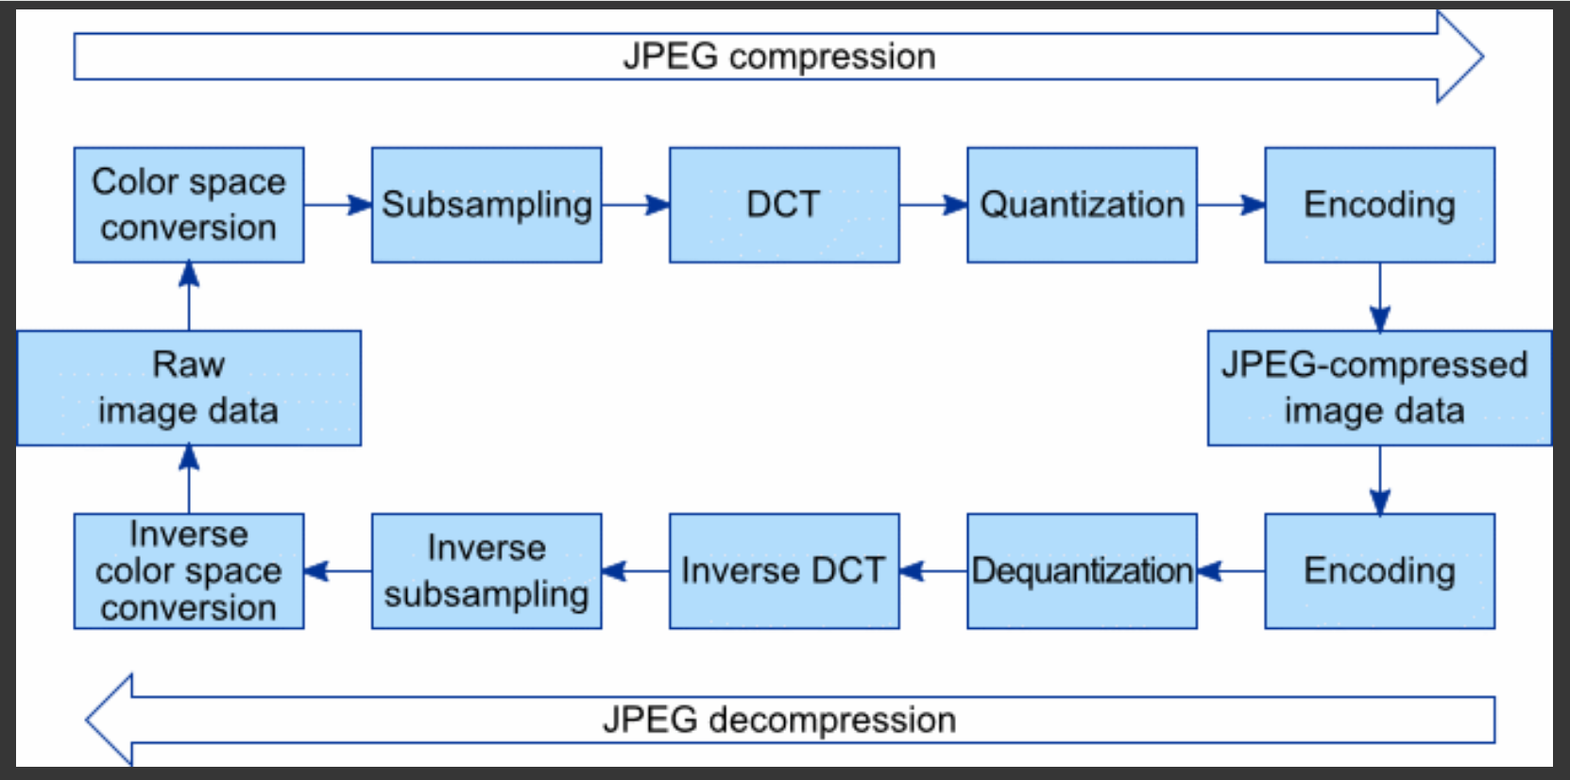

Sub – Band Coding :
Subband coding (SBC) in digital image processing is a lossy compression technique that decomposes an image into different frequency subbands (low-pass approximation and high-pass details) using digital filters. Low-pass filters (LPF) smooth images by attenuating high-frequency noise and details, while high-pass filters (HPF) sharpen images by highlighting edges and fine details. Each subband is then independently quantized and encoded, allowing for higher compression by focusing bits on critical visual information.
Key Aspects of Subband Coding:
- Process: The image is first passed through a bank of analysis filters to split it into multiple frequency bands (e.g., Low-Low, Low-High, High-Low, High-High).
- Decimation/Downsampling: Because the subbands have narrower bandwidths, they can be downsampled (decimated) without losing information. Downsampling removes data (decimation) to decrease size, while upsampling increases data points (interpolation) to increase size
- Quantization and Encoding: Each subband is quantized differently; generally, the low-frequency (approximation) subband is coded with higher precision, while high-frequency (detail) subbands are compressed more heavily.
- 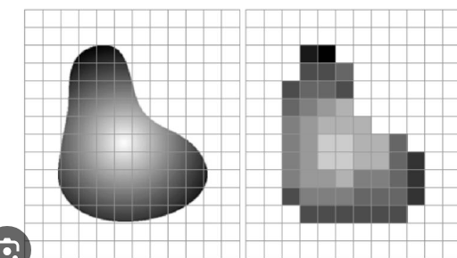
- Reconstruction (Synthesis): To reconstruct the image, the subbands are upsampled, passed through synthesis filters, and combined.
- Applications: It is widely used in image compression, including video coding (HDTV) and standards like JPEG 2000, which utilize discrete wavelet transforms (a form of subband coding).
- Filters: Common filters include Quadrature Mirror Filters (QMF) and Smith-Barnwell filters.
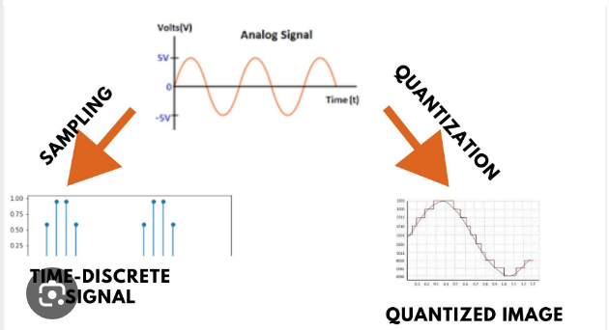

Sampling in image processing is the process of converting a continuous, analog image into a discrete, digital format by selecting specific, finite data points to represent the whole.
Image sampling and image quantization are two fundamental steps in converting real-world images into digital form. Sampling determines how many pixels are used to represent an image, while quantization decides how many intensity levels or colours each pixel can store. Together, they control the quality, clarity and file size of digital images
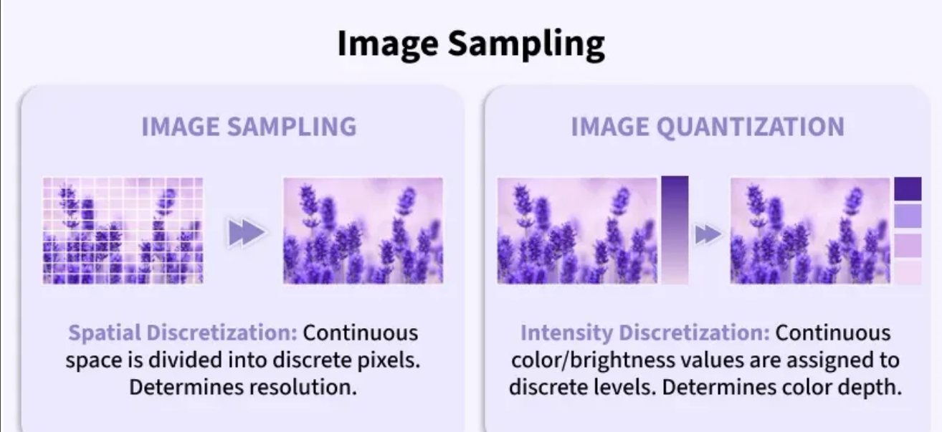
1. Image Sampling
Image sampling is the process of converting a continuous image into a discrete form by selecting a finite number of points (pixels) from the image plane. It deals with spatial resolution i.e how many pixels are used to represent the image in horizontal and vertical directions. In simple terms, sampling determines where pixel values are taken from the image.
- Converts continuous spatial coordinates into a discrete grid.
- Directly controls image resolution (e.g., 256×256, 512×512).
- Higher sampling rate means more pixels which means more detail.
- Lower sampling rate means fewer pixels leading to loss of spatial detail.
- Poor sampling can cause aliasing effects.
Use Cases
- Digital cameras: Determining sensor resolution.
- Medical imaging: CT and MRI scan resolution control.
- Satellite imagery: Choosing ground spatial resolution.
- Image resizing: Downsampling or upsampling images.
2. Image Quantization
Image quantization is the process of mapping a large set of continuous or discrete intensity values to a smaller, finite set of intensity levels. It deals with intensity resolution i.e how many grey levels or colors are used to represent pixel values. In simple terms, quantization determines how accurately pixel values are represented.
- Converts continuous intensity values into discrete levels.
- Controls the number of grey levels or colors.
- More levels means smoother intensity transitions.
- Fewer levels means visible banding and distortion.
- Quantization introduces quantization error.
Working
- Pixel intensity values are first sampled.
- A finite set of intensity levels is defined (e.g., 8-bit → 256 levels).
- Each pixel value is rounded to the nearest allowed level.
- The difference between original and assigned value is the quantization error.
- The result is a digitally representable image.
Use Cases
- Image storage: Reducing memory requirements.
- Image compression: JPEG and PNG encoding.
- Display systems: Limited color depth screens.
- Computer vision: Simplifying intensity ranges for processing

- Audio compression Techniques –
Audio compression techniques reduce file sizes or manage dynamic range through lossy (data removal) or lossless (data reduction) methods.

Audio compression is a process that reduces the amount of data required to represent audio signals, enabling more efficient storage and transmission of audio information in digital systems.
In computer science, audio compression is essential for multimedia applications, as raw audio data, such as CD-quality audio sampled at 44.1 kHz with 16 bits per sample, results in enormous file sizes that are impractical for transmission and storage without compression. Compression techniques remove redundancy from audio data, allowing the same or nearly the same information to be represented using fewer data bits, a process known as source coding.

Analog audio is a continuous signal, whereas digital audio is a sequence of discrete values. In computer systems, digital audio is stored as a sequence of 0’s and 1’s. The process of converting analog audio to digital involves sampling the analog wave at regular intervals and quantizing the amplitude of each sample to a discrete value. The sample rate measures how often per second the amplitude is taken, and the bit depth determines the possible digital values for each sample. For example, pulse code modulation (PCM) is a standard form of digital audio that uses a specific sample rate and bit depth to represent audio in an uncompressed, lossless format.

Principles and Techniques of Audio Compression
Audio compression is the process of reducing the size of digital audio files so they require less storage space and bandwidth while maintaining acceptable sound quality. It is widely used in multimedia systems, streaming platforms, and digital broadcasting.
Audio compression is based on removing redundant and irrelevant information from the audio signal.
1. Redundancy Reduction
Redundancy means repeated or predictable data in the audio signal.
Two main types of redundancy:
a) Temporal Redundancy
- Occurs when consecutive audio samples are similar.
- Compression algorithms store differences instead of full values.
b) Spatial (Statistical) Redundancy
- Some audio sample values occur more frequently than others.
- Efficient coding methods assign short codes to frequent values.
2. Irrelevancy Reduction
The human ear cannot hear all sounds equally.
Audio compression removes sounds that are inaudible or less important to human perception.
This principle is based on psychoacoustics, which studies how humans perceive sound.
3. Psychoacoustic Model
A psychoacoustic model identifies sounds that the human ear cannot detect.
Two main masking effects:
a) Frequency Masking
- A strong sound at one frequency can mask weaker sounds at nearby frequencies.
Example:
A loud drum beat may hide softer background sounds.
b) Temporal Masking
- Loud sounds can mask quieter sounds occurring immediately before or after them.
Using these effects, compression algorithms remove masked sounds, reducing data size.
2. Techniques of Audio Compression
Audio compression techniques are mainly classified into Lossless and Lossy compression.
1. Lossless Audio Compression
Lossless compression reduces file size without losing any audio data.
The original audio can be perfectly reconstructed after decompression.

Techniques used:
- Run Length Encoding (RLE)
- Huffman Coding
- Arithmetic Coding
Example formats:
- FLAC
- ALAC
Advantages
- No loss of sound quality
- Exact reconstruction of original data
Disadvantages
- Lower compression ratio
- Larger file size compared to lossy methods
2. Lossy Audio Compression
Lossy compression removes less important audio information to achieve higher compression.
The decompressed audio is not identical to the original, but the difference is usually not noticeable.
Techniques used:
- Perceptual Coding
- Transform Coding
- Quantization
- Bit rate reduction
Examples:
- MP3
- AAC
Advantages
- Very high compression ratio
- Smaller file sizes
- Ideal for streaming and mobile devices
Disadvantages
- Some loss of audio quality
- Cannot perfectly reconstruct the original audio

- Applications and Future Trends in Audio Compression

Audio compression is widely used in multimedia and communication systems:
- Music streaming platforms like Spotify
- Video streaming services like YouTube
- Mobile communication
- Internet radio
- Video conferencing
- Digital broadcasting

Audio compression is essential for applications where large amounts of audio data must be stored or transmitted, such as digital audio broadcasting and internet streaming. Audio processing techniques, including audio compression, are widely used in speech recognition systems, music classification, sound event detection, noise reduction, audio restoration, medical imaging, forensic analysis, and virtual assistants. Compression of speech signals reduces the number of data bits present in the input speech sample, facilitating faster transmission and reception, which improves communication.

5. Advantages of Audio Compression
- Reduces storage space
- Enables faster transmission over networks
- Makes streaming possible
- Reduces bandwidth usage
- Efficient multimedia storage

- A-Law companding:
A-law companding is a standard logarithmic compression technique defined in the G.711 used mainly in European and Indian digital telephony systems. It is designed to improve the quality of voice signals by reducing the effects of noise during digital transmission.
1. Meaning of Companding
The word companding comes from two terms:
- Compression – reducing the dynamic range of the signal before transmission.
- Expanding – restoring the signal to its original form at the receiver.
It is a technique used in digital communication systems to improve the signal-to-noise ratio (SNR) of a transmitted signal. The technique involves compressing the dynamic range of the signal before transmission and then expanding it back to its original range after reception.
- Key Features of A-Law Companding
- Purpose and Functionality
It compresses the wide dynamic range of human speech, allowing smaller signals to be represented with more precision (higher Signal-to-Distortion Ratio) than larger ones, improving the signal-to-noise ratio (SNR) in 8-bit digital systems.

In digital telephony, voice signals are first converted from analog to digital using Pulse Code Modulation (PCM). Human speech has a wide dynamic range, meaning some parts of speech are loud while others are very soft.

A-law companding:
- Compresses the signal before quantization.
- Expands it back after decoding.
- Reduces quantization noise, especially for low-amplitude signals.
- Improves signal-to-noise ratio (SNR) for speech.

3. Working Principle
The process includes two main stages:
1. Compression (Transmitter side)
The analog signal amplitude is compressed using a logarithmic function. Small signals are amplified more than large signals.
2. Expansion (Receiver side)
At the receiving end, the signal is expanded using the inverse logarithmic function to recover the original waveform.

- 2. Mathematical Representation
- Compression Equation: The A-Law companding function can be mathematically expressed as follows:
- F(x) = sgn(x) A |x| / (1 + lnA) 0 ≤ |x| < 1/A
- = sgn(x) (1+ln A|x|) /(1 + lnA) 1/A ≤ |x| ≤ 1
- where A is the compression parameter (A=87.6 in Europe), and x is the normalized integer to be compressed.​
- 3. Implementation
- Bit Reduction: A-Law companding typically converts linear sample values (usually 13 bits) into compressed 8-bit values. This reduction allows for efficient data transmission while maintaining audio quality.
- Encoding and Decoding: The process involves encoding the audio signal into a compact form using the defined mathematical model and then decoding it back to its original form during playback or processing.
5. Applications
- A-law companding is used in:
- Digital telephone networks in Europe and India
- Voice communication systems
- VoIP gateways
- PCM-based telecommunication systems
6. Advantages
- Reduces quantization noise for low-level signals
- Improves voice quality during transmission
- Efficient use of limited bandwidth
- Standardized method for digital telephony

- Frequency domain and filtering:
Frequency domain analysis and filtering are fundamental concepts in signal processing, providing insights into how signals behave with respect to frequency rather than time. This approach is crucial for applications across various fields, including telecommunications, audio processing, and image analysis. Frequency domain is a way of representing a signal based on its frequency components instead of time. In the time domain, a signal is described as how it changes over time, whereas in the frequency domain, the signal is described as a combination of different frequencies.
Signals such as audio, images, or videos can be transformed from the time domain to the frequency domain using mathematical tools like the Fourier Transform or Discrete Fourier Transform. These transforms break a complex signal into a set of sinusoidal components with different frequencies.
Frequency Domain Analysis
Definition
The frequency domain refers to the representation of signals in terms of their frequency components rather than their amplitude over time. In this domain, a signal is expressed as a sum of sinusoidal functions (sine and cosine waves) at different frequencies, each with a specific amplitude and phase.
Key Concepts
- Fourier Transform: The primary mathematical tool for converting a time-domain signal into its frequency-domain representation. The Fourier Transform decomposes a signal into its constituent frequencies, allowing for analysis of how much energy exists at each frequency.
- Magnitude and Phase: The output of the Fourier Transform is complex, consisting of both magnitude (the strength of each frequency component) and phase (the timing of these components). Understanding both aspects is essential for reconstructing the original signal from its frequency components.
Filtering in the Frequency Domain
Definition
Filtering involves modifying or manipulating a signal to enhance certain aspects while attenuating others. In the frequency domain, filtering allows for selective amplification or suppression of specific frequency components. Frequency domain filtering is a crucial technique in image processing that involves manipulating the frequency components of an image to achieve various enhancements. This method differs from spatial domain filtering, which operates directly on pixel values. Instead, frequency domain filtering leverages the Fourier Transform to analyze and modify the frequency content of images.
Types of Filters
- Low-Pass Filter (LPF): Allows low-frequency signals to pass through while attenuating higher frequencies. This is useful for removing high-frequency noise from signals.
- High-Pass Filter (HPF): Opposite of LPF; it allows high-frequency signals to pass while attenuating lower frequencies. This can be used to eliminate DC offsets or low-frequency noise.
- Band-Pass Filter (BPF): Permits a specific range of frequencies to pass while attenuating frequencies outside this range. BPFs are often used in applications like audio equalization.
- Notch Filter: Specifically designed to attenuate a narrow band of frequencies while allowing others to pass. This is useful for eliminating specific interference signals.
Implementation
Filtering in the frequency domain typically involves:
- Transforming the Signal: Use the Fourier Transform to convert the time-domain signal into its frequency-domain representation.
- Applying the Filter: Modify the frequency components according to the filter's characteristics (e.g., setting certain frequencies to zero).
- Inverse Transforming: Apply the inverse Fourier Transform to convert the modified frequency-domain representation back into the time domain.
Applications
- Audio Processing: Frequency domain filtering is widely used in equalization, noise reduction, and audio effects processing.
- Telecommunications: Filters are essential for managing bandwidth and reducing interference in communication channels.
- Image Processing: Techniques such as edge detection and image enhancement often utilize frequency-domain methods.
- Audio signal processing
- Image enhancement
- Noise reduction
- Communication systems
- Multimedia compression
Application to speech coding - G.722
- G.722 is an ITU-T standard for a wideband audio codec designed to provide high-quality digital speech coding. It operates with a signal bandwidth of 50 Hz to 7 kHz and is capable of transmitting data at rates of 48, 56, and 64 kbit/s. This codec is particularly significant in various applications due to its efficient compression and superior audio quality compared to traditional narrowband codecs.
- ITU-T, or the International Telecommunication Union Telecommunication Standardization Sector.
- Established in 1956, ITU-T is responsible for developing and coordinating international standards for telecommunications and information communication technologies (ICTs).
- Applications
- G.722 is widely used in various applications, including:Voice over IP (VoIP): Its high-quality audio makes it suitable for VoIP applications where bandwidth is available.
- ISDN Systems: It allows for high-quality digital speech transmission in Integrated Services Digital Networks.
- Videophones: The codec enhances audio quality in videoconferencing systems, providing clearer communication.
- Broadcasting: Radio broadcasters often use G.722 for transmitting commentary-grade audio over ISDN channels.

- MPEG audio.
MPEG audio refers to a set of audio coding standards developed by the Moving Picture Experts Group (MPEG), which is part of the International Organization for Standardization (ISO). These standards are designed to compress audio data efficiently while maintaining high quality, making them widely used in various applications, including digital broadcasting, streaming, and storage.
Key MPEG Audio Standards
- MPEG-1 Audio:
  - Layers: Includes three layers—Layer I (MP1), Layer II (MP2), and Layer III (MP3).
  - Compression: MP3, the most famous of these, uses lossy compression to significantly reduce file sizes while preserving sound quality.
  - Sampling Rates: Supports rates of 32, 44.1, and 48 kHz with various bit rates ranging from 32 to 384 kbit/s.
- MPEG-2 Audio:
  - An extension of MPEG-1 that includes additional sampling rates (16, 22.05, and 24 kHz) and bit rates.
  - Supports multichannel audio up to 5.1 channels, enhancing the audio experience in applications like home theater systems.
- MPEG-4 Audio:
  - Offers advanced features such as support for multiple audio channels, enhanced error resilience, and tools for streaming.
  - Includes formats like AAC (Advanced Audio Codec), which is widely used in streaming services due to its efficiency at lower bit rates.
Applications of MPEG Audio
- Digital Broadcasting: MPEG audio standards are used in digital radio and television broadcasting systems.
- Streaming Services: Platforms like YouTube and Spotify utilize MPEG audio formats for efficient streaming.
- Multimedia Storage: MPEG audio formats are commonly used in CDs, DVDs, and other digital media.
Advantages of MPEG Audio
- Compression Efficiency: Reduces file sizes significantly without a substantial loss in quality.
- Interoperability: Supported across various devices and platforms due to its widespread adoption.
- Flexibility: Different layers and formats allow for a range of applications from low-bitrate streaming to high-fidelity audio playback.

- Video compression techniques and Standards
Video compression techniques are essential for reducing the size of video files while maintaining acceptable quality, enabling efficient storage and transmission. Various standards have been developed to implement these techniques, each with its own advantages and applications. Video compression is the process of reducing the size of digital video files so that they require less storage space and bandwidth while maintaining acceptable visual quality. It is widely used in multimedia systems, video streaming, video conferencing, and broadcasting.
Types of Video Compression Techniques
- Lossy Compression:
  - Definition: This technique reduces file size by permanently removing some data from the video, resulting in a loss of quality. It is the most common method used for streaming and storage.
- Lossless Compression:
Definition: This method compresses video files without losing any data, ensuring that the original quality is preserved.
Applications: Often used in professional video editing and archiving where fidelity is crucial.

- Intra-frame Compression (Spatial): Compresses each frame individually, treating them like still images (e.g., Motion JPEG, ProRes).
Intra-frame compression (spatial compression) is a method that compresses each video frame independently, treating them as individual, high-quality still images (e.g., Motion JPEG, ProRes, DV). Unlike inter-frame compression, it does not rely on previous or future frames to reduce data, which makes it ideal for editing and post-production, albeit resulting in larger file sizes.

Key Aspects of Intra-frame Compression
- Methodology: It reduces file size by removing redundant information within a single frame (spatial redundancy).
- Performance & Editing: Because every frame is self-contained, intra-frame codecs are easier for computers to decode and edit, offering better performance in professional video editing software.
- Quality: It generally provides higher, more consistent image quality than inter-frame methods because it does not rely on motion prediction between frames.
- Use Cases: It is heavily used in production environments, professional cameras, and during post-production (e.g., Apple ProRes, Avid DNxHD, DVCProHD).

Examples of Intra-frame Codecs

- Apple ProRes: A professional intermediate codec optimized for editing.
- Motion JPEG (M-JPEG): Compresses each frame as a JPEG image.
- All-I (All-Intra): Found in cameras like the Canon 5D Mark III.
- RAW: While technically uncompressed or lightly compressed data rather than "intra-frame" in the traditional sense, it is often grouped with it due to its independent frame nature

- Inter-frame Compression (Temporal): Compresses by analyzing differences between consecutive frames, reducing redundancy over time (e.g., MPEG, H.264, H.265).
Inter-frame compression (temporal) reduces video file size by encoding only the changes between frames rather than every full image, exploiting the high redundancy in consecutive video frames. It uses reference frames (I-frames) and motion compensation to predict subsequent frames (P-frames/B-frames), significantly increasing efficiency compared to intra-frame methods.

Key Aspects of Inter-frame Compression:
- Temporal Redundancy: Takes advantage of the fact that consecutive frames in a video are often nearly identical, with little changing other than moving objects.
- Keyframes and Predicted Frames: The process relies on "I-frames" (Intra-coded frames) as full-image reference points, while "P-frames" (Predicted) and "B-frames" (Bi-predictive) store only the difference (residual) between the current and reference frames.
- Motion Estimation: The encoder divides frames into blocks and searches for matching blocks in previous or future frames to calculate motion vectors, which describe how objects move.
- Efficiency: It is essential for streaming and efficient storage, as it can be up to three times more efficient than intra-frame-only compression, which processes each frame independently.
- Examples: Common codecs utilizing this method include MPEG-2, MPEG-4, and H.264/AVC.

- MPEG video coding: MPEG-1 and MPEG-2 video coding: MPEG-3 and MPEG-4.
MPEG (Moving Picture Experts Group) has developed several video coding standards to efficiently compress and transmit audio-visual content. The most notable among these are MPEG-1, MPEG-2, and the later MPEG-4. Below is a detailed overview of each standard.
MPEG-1
- Introduction: Released in 1993, MPEG-1 was designed for coding moving pictures and associated audio for digital storage media at bit rates up to about 1.5 Mbit/s. It was primarily aimed at achieving video quality comparable to VHS tapes.
- Key Features:
Compression: Utilizes lossy compression, focusing on the differences between frames (motion compensation) to reduce data size.
Video Quality: Provides moderate quality suitable for applications like Video CDs and early internet streaming.
Audio Layer: Includes the famous MP3 audio format (MPEG-1 Audio Layer III), which compresses audio while preserving quality.
- Applications: Commonly used for Video CD, low-quality DVD video, and digital satellite/cable TV services before the advent of MPEG-2 .
MPEG-2
- Introduction: Developed in 1995, MPEG-2 improved upon MPEG-1 by supporting higher-quality video and interlaced images, making it suitable for broadcast television and DVDs.
- Key Features:
Higher Bit Rates: Supports transmission rates exceeding 4 Mbit/s, allowing for better quality video.
  - Interlaced Video Support: Designed to handle both progressive and interlaced video formats, which is essential for television broadcasts.
  - Backward Compatibility: MPEG-2 players can decode MPEG-1 streams, ensuring a smooth transition from older formats.
  - Applications: Widely used in DVD productions, digital television broadcasts (including HDTV), and Video on Demand services .
MPEG-3
- Status: Initially intended for high-definition television, MPEG-3 was ultimately deemed unnecessary as its requirements were incorporated into MPEG-2. Therefore, it is not widely recognized or used .
MPEG-4
- Introduction: Released in 1998, MPEG-4 was designed to provide advanced compression techniques that support multimedia applications.
- Key Features:
  - Low-Bandwidth Encoding: Optimized for low-bandwidth scenarios while maintaining high-quality audio and video.
  - Object-Based Coding: Allows for the encoding of individual objects within a scene, enhancing interactivity and multimedia capabilities.
  - Versatility: Supports a wide range of applications from streaming media to mobile devices.
- Applications: Commonly used in internet streaming, portable media players, and interactive multimedia applications due to its efficient compression and flexibility .
